DBMS Lab Assignment 1

Neeti Kurulkar

Draw E-R Diagram for ‘Bank Management System’ and also draw relational tables and normalize relational data model.

Diagrams:

1. E-R Diagram for Bank Management System

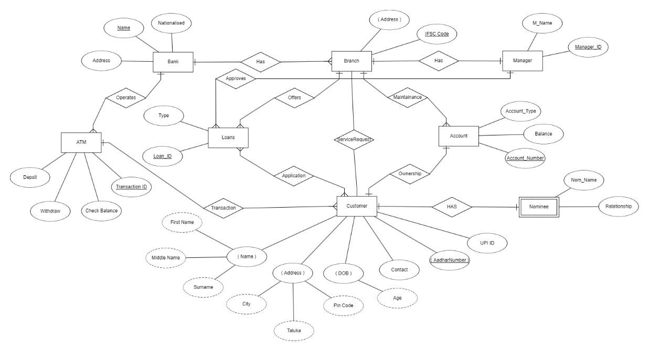

1. Relational Data Model

